CAP 4611 Assignment 2
Cameron D Lewis
UCFID 5593788
Section 01
09/14/25
- K Nearest Neighbors
distances_squared = euclidean_dist_squared(X_hat, self.X)
for i in range(n_test):
# Get distances
distances_i = distances_squared[i, :]
# Find indices of k nearest neighbors
nearest_indices = np.argsort(distances_i)[:self.k]
# Get labels of k nearest neighbors
nearest_labels = self.y[nearest_indices]
# Use mode to find most common label
predictions[i] = utils.mode(nearest_labels)
return predictions
  - KNN Results:
k=1 Training error = 0.000 Test error = 0.065
k=3 Training error = 0.028 Test error = 0.066
k=10 Training error = 0.058 Test error = 0.085

Decision Tree comparison:
Decision Tree: Training error = 0.000, Test error = 0.078Plot
  - 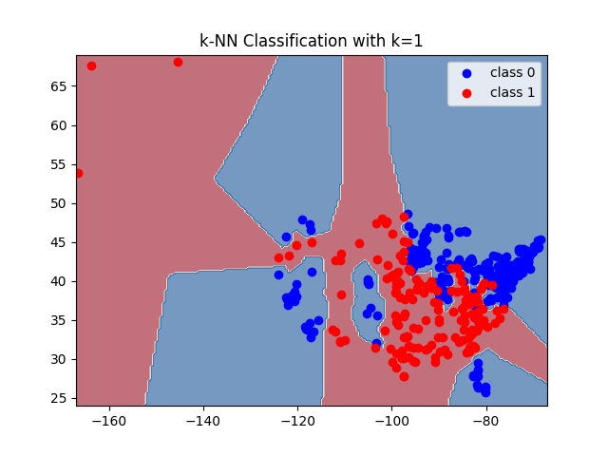
  - When k=1, each point is classified based on its single nearest neighbor which is itself resulting in a 0% training error
  - Use cross validation
- Picking K in KNN
n = X.shape[0]
# 10-fold cross-validation
fold_size = n // 10
cv_accs = []
test_accs = []
train_accs = []
for k in ks:
# Cross-validation accuracies
fold_accs = []
for fold in range(10):
# Create mask for this fold
mask = np.ones(n, dtype=bool)
start_idx = fold * fold_size
if fold == 9:
end_idx = n
else:
end_idx = (fold + 1) * fold_size
# Set validation indices to False
mask[start_idx:end_idx] = False
# Split data
X_train_fold = X[mask]
y_train_fold = y[mask]
X_val_fold = X[~mask]
y_val_fold = y[~mask]
# Train and evaluate
model = KNN(k=k)
model.fit(X_train_fold, y_train_fold)
y_pred_val = model.predict(X_val_fold)
fold_accuracy = np.mean(y_pred_val == y_val_fold)
fold_accs.append(fold_accuracy)
# Store mean accuracy
cv_accs.append(np.mean(fold_accs))
# compute test accuracy
model_full = KNN(k=k)
model_full.fit(X, y)
# Training accuracy
y_pred_train = model_full.predict(X)
train_accuracy = np.mean(y_pred_train == y)
train_accs.append(train_accuracy)
# Test accuracy
y_pred_test = model_full.predict(X_test)
test_accuracy = np.mean(y_pred_test == y_test)
test_accs.append(test_accuracy)
# Plot cross-validation and test accuracies
plt.figure(figsize=(10, 6))
plt.plot(ks, cv_accs, 'b-o', label='Cross-validation accuracy')
plt.plot(ks, test_accs, 'r-s', label='Test accuracy')
plt.xlabel('k')
plt.ylabel('Accuracy')
plt.title('Cross-validation vs Test Accuracy')
plt.legend()
plt.grid(True)
plt.savefig("../figs/cv_vs_test_accuracy.png")
print("CV vs Test accuracy plot saved as ../figs/cv_vs_test_accuracy.png")
# Plot training error
plt.figure(figsize=(10, 6))
train_errors = [1 - acc for acc in train_accs]
plt.plot(ks, train_errors, 'g-^', label='Training error')
plt.xlabel('k')
plt.ylabel('Training Error')
plt.title('Training Error vs k')
plt.legend()
plt.grid(True)
plt.savefig("../figs/training_error_vs_k.png")
print("Training error plot saved as ../figs/training_error_vs_k.png")
# Find best k values
best_cv_k = ks[np.argmax(cv_accs)]
best_test_k = ks[np.argmax(test_accs)]
print(f"\nResults:")
print(f"Best k according to cross-validation: {best_cv_k} (CV accuracy: {max(cv_accs):.3f})")
print(f"Best k according to test accuracy: {best_test_k} (Test accuracy: {max(test_accs):.3f})")
print(f"CV-chosen k test accuracy: {test_accs[ks.index(best_cv_k)]:.3f}")

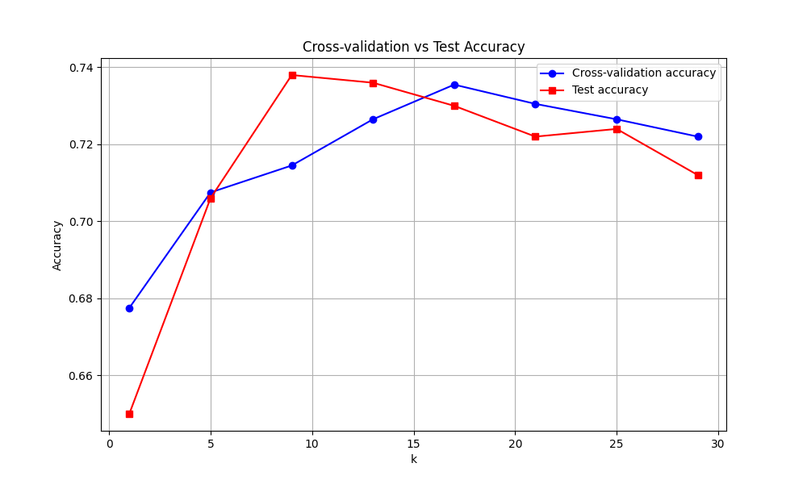

The cross-validation would most likely choose 17 as it has the highest accuracy and it would do good because the CV chosen k is similar in accuracy to the best k chosen by test accuracy
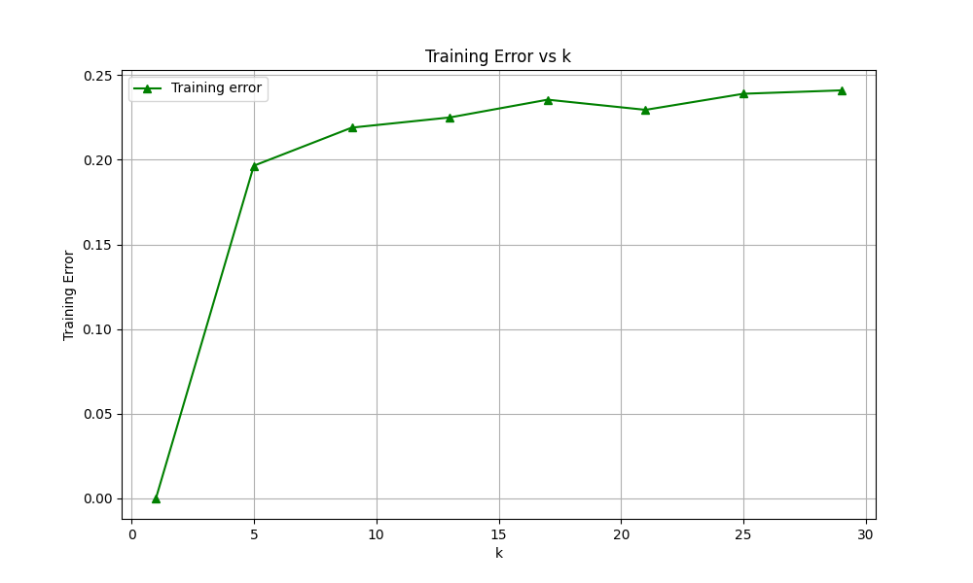
The k with the best training error is k=1 0% but that is skewed and would likely do poorly on test data
- Naïve Bayes
  - 3.1
    - .6 and .4
    - 1/6, 5/6,2/6, ¾, ¼, ¾,
    - Pr( = 1 | spam) * Pr(lottery = 1 | spam)* Pr(Venmo = 0 | spam) = .0463
Pr( = 1 | notspam) * Pr(lottery = 1 | notspam)* Pr(Venmo = 0 | notspam) = .1406
.0436<.1406 so it would most likely not be spam
    - [ 0 0 0 spam
1 1 1 not spam insert these extra rows into the original
0 0 0 spam
1 1 1] not spam
  - 3.2
    - Word at column 73 (index 72): question
    - Words present in example 803: ['case', 'children', 'health', 'help', 'problem', 'program']
    - Example 803 belongs to the newsgroup: talk.*
  - 3.3
p_xy = np.zeros((d, k))
for c in range(k):
# Find examples belonging to class c
class_mask = (y == c)
n_c = np.sum(class_mask)
if n_c > 0:
for j in range(d):
feature_count = np.sum(X[class_mask, j])
p_xy[j, c] = feature_count / n_c
self.p_y = p_y
self.p_xy = p_xy

    - Naive Bayes training error: 0.200
Naive Bayes validation error: 0.188
  - 3.4
p_xy = np.zeros((d, k))
for c in range(k):
# Find examples belonging to class c
class_mask = (y == c)
n_c = np.sum(class_mask)
for j in range(d):
feature_count = np.sum(X[class_mask, j])
# Apply Laplace smoothing
p_xy[j, c] = (feature_count + self.beta) / (n_c + 2 * self.beta)
self.p_y = p_y
self.p_xy = p_xy

    - Yes some probability was 0 before and after doing B=1 none of them are zero anymore
    - Yes because as the smoothing becomes too intensive the outcomes become equally as likely
  - 3.5
    - O(tkd)

- Random Forests
  - Because the random tree only looks at a subset of features at each split
  - Splits stop when no further improvements are made
def __init__(self, num_trees, max_depth):
self.num_trees = num_trees
self.max_depth = max_depth
self.trees = []
def fit(self, X, y):
self.trees = []
for i in range(self.num_trees):
# Create a new RandomTree
tree = RandomTree(max_depth=self.max_depth)
# Fit the tree to the data
tree.fit(X, y)
# Add to our forest
self.trees.append(tree)
def predict(self, X_pred):
n = X_pred.shape[0]
# Get predictions from all trees
tree_predictions = np.zeros((self.num_trees, n))
for i, tree in enumerate(self.trees):
tree_predictions[i] = tree.predict(X_pred)
# For each example, take the mode across all trees
predictions = np.zeros(n)
for i in range(n):
predictions[i] = utils.mode(tree_predictions[:, i])
return predictions

  - Training error: 0.000
Testing error: 0.170
  - Random forests typically have 0 training error because with enough trees the ensemble can memorize the training data
- Clustering
  - 5.1
total_error = 0
for i in range(X.shape[0]):
# Get the assigned cluster for example i
cluster = y[i]
# Compute squared distance from example i to its assigned mean
diff = X[i] - means[cluster]
squared_dist = np.sum(diff ** 2)
total_error += squared_dist
return total_error

    - Error decreases with each iteration
    - 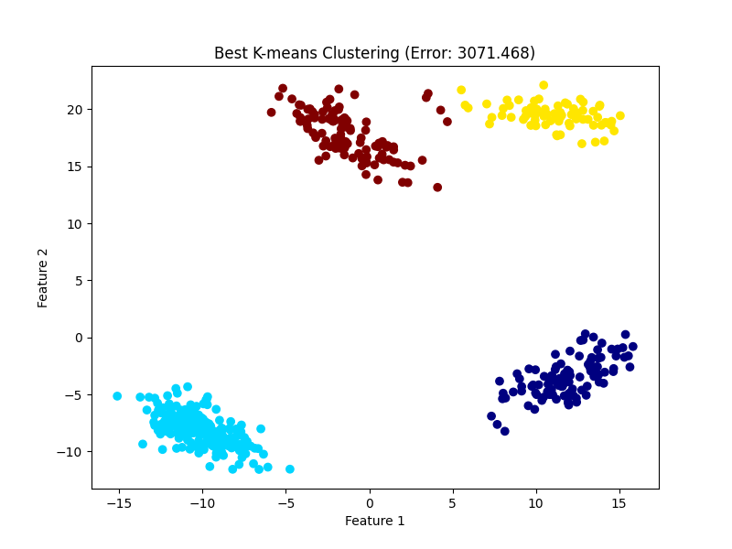
Lowest error obtained: 3071.468
  - 5.2
    - Error decreases as k increases reaching 0 when k=n
    - No because clustering is unsupervised
    - 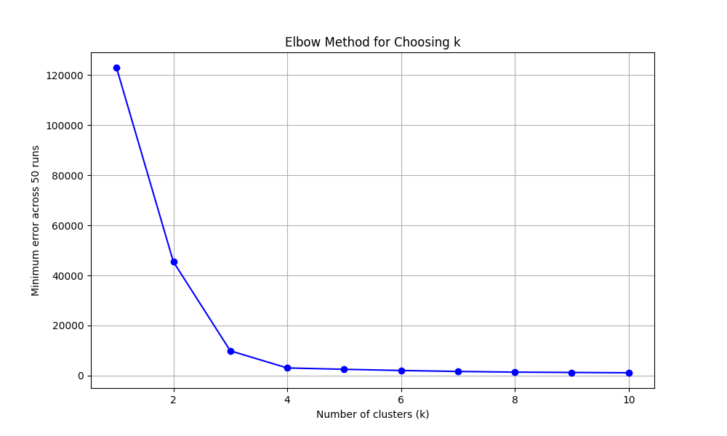
    - I would choose k=3 since the slope is quite large and the data wouldn’t be as black and white as say k=2
- Very Short Answer Questions
  - If emails come from the same sender, it could violate the independence assumption
  - It usually leads to overfitting and poor generalization of new data
  - As n increases, optimization bias decreases
  - Advantage, more training data per fold Disadvantage, higher cost
  - P(xi) is the same for all classes

    - parameter
    - parameter
    - hyperparameter
  - labeled training data vs patterns in unlabeled data
  - No it can be non convex

